Ceasefire Outdoor & Perimeter Detectors

The risk begins far beyond your front door.

Security measures that alert you to break-ins to

your premises still leave you vulnerable. That’s because they allow the threat to infiltrate the building before alerting you. Not only does this put you in danger, it needlessly endangers your loved ones and your property.

Appointing security guards might provide a measure of security, but it doesn’t ensure your property is completely secured. Not only is there room for human error on the part of the most diligent guard, all it takes is a moment’s inattention for burglars to force their way into your property.

When it comes to threats, an offensive approach is always better than a defensive one. Keeping the need for intensive security measures in mind, Ceasefire now provides a foolproof security system that stops burglars in their tracks, before they can penetrate your property. Ceasefire presents Vigil – an alarm-based security system that secures the gates and walls around your property.

Using dual infra-red detectors to detect unusual activity, Vigil raises the alarm if the walls surrounding your property are breached or if your gate is threatened. Not only does this revolutionary system assure you of the security of your property, the alarm and alerting systems serve as a deterrent to potential threats.



Vigil is ideal for private homes and villas, factories, residential societies, offices, malls, corporate parks and commercial complexes. After all, it’s perfectly equipped to keeps your property’s perimeter well protected, keeping threats where they belong – outside!

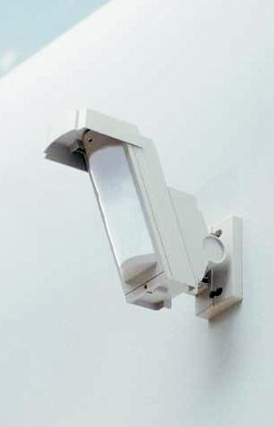

How Vigil works

Dependable and untiring, Vigil never takes a break. Vigil offers a 24x7 security solution, virtually sealing off your gates and the boundary walls around your property from intruders. Featuring dual infra-red sensors with different ranges that can differentiate between environmental disturbances and genuine threats, Vigil ensures that danger cannot come unannounced – ever!

Vigil offers multiple types of outdoor and perimeter detectors – AX AIR, HX – PIR, VX PIR , BX PIR and FIT PIR – that can be installed according to the characteristic of your property.

Offering wireless convenience, stylish design and dual detection zones for superior stability and improved false alarm protection for reliability, Vigil’s detectors are also weather proof and have been designed to be environmentally responsive to ensure customisable installation.

Co-ordinating the network of perimeter detectors is a state-of-the-art Control Panel, that sets off a piercing alarm as well as alerts you of the intruders.

Outdoor Sensor

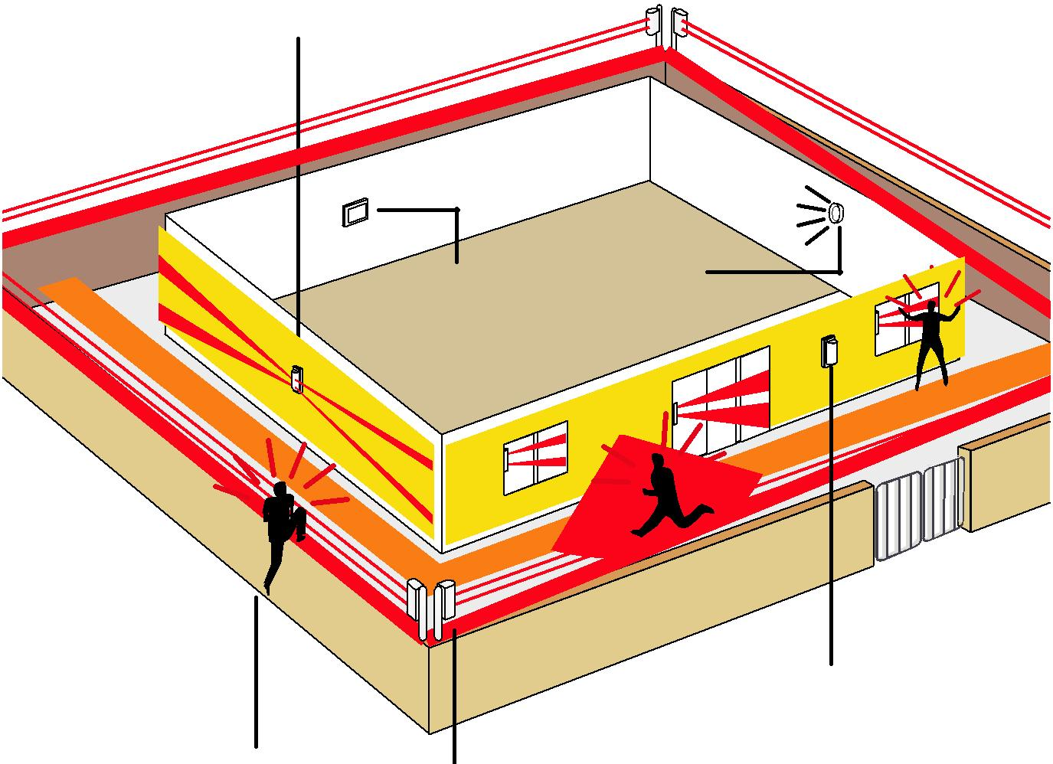

|  |  |  |
| --- | --- | --- |
| Control Panel | Sound |  |
| Alarm |  |

Outdoor Sensor

Outdoor Sensor

|  |  |  |  |
| --- | --- | --- | --- |
| Intruder |  | Outdoor Sensor |  |
|  |  |
|  |  |  |



The 3-Tier Defence levels

**Defence Level**



Perimeter area: Outer boundary

Sensor: AX 100/200 TFR

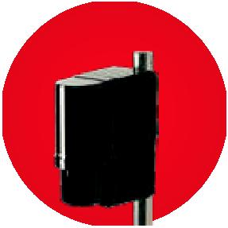

**Defence Level**



Middle area: Compound

Sensor: HX - PIR / VX - PIR

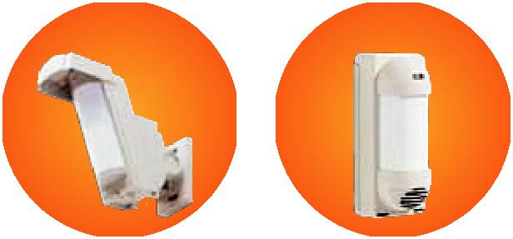

**Defence Level**



Wall area: Windows and Entrances

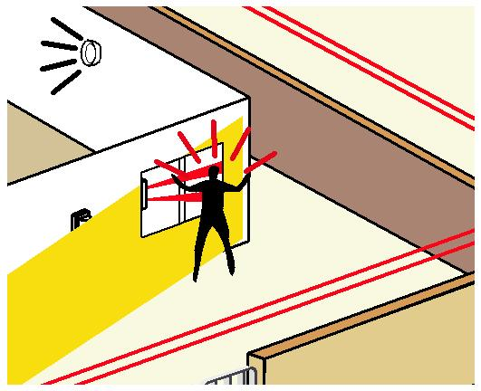

Sensor: FIT PIR / BX PIR

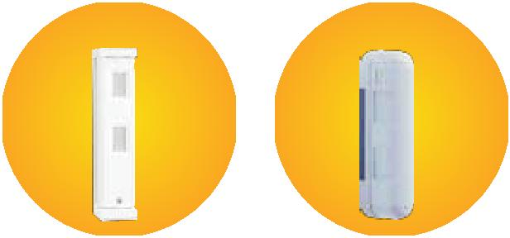

Vigil and how it can secure your property

**Villas**

Vigil’s 3-tier defence alerts you about out-of-the-ordinary occurrences such as a burglar scaling the

compound walls or cutting your gates.

**Defence Level Defence Level Defence Level**

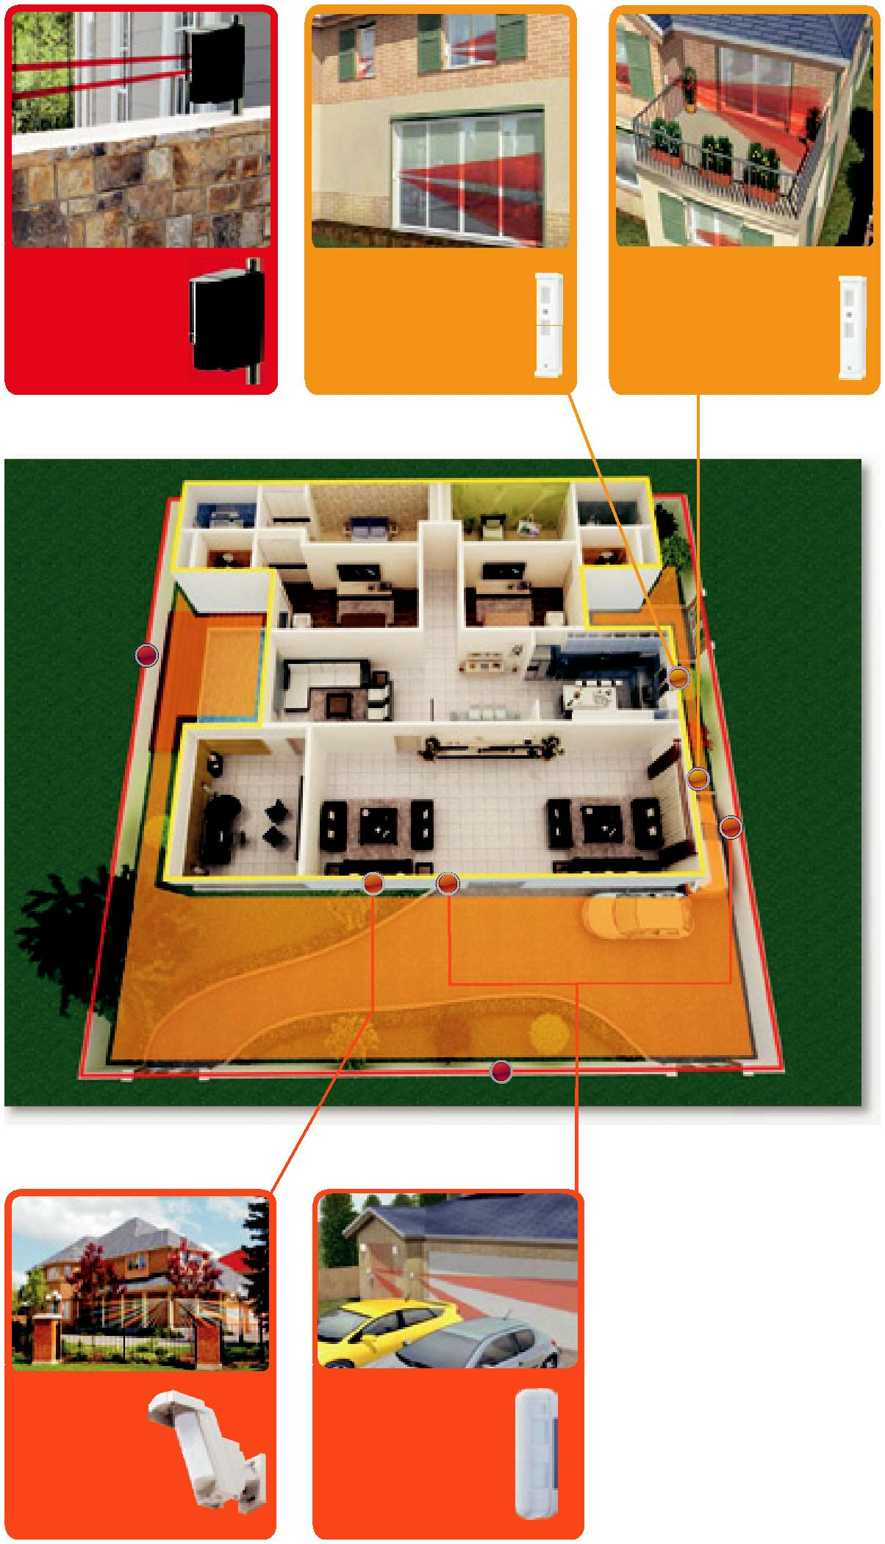

|  |  |  |  |  |  |  |  |
| --- | --- | --- | --- | --- | --- | --- | --- |
|  | OUTDOOR COMPACT |  |  |  |  |  |  |
|  | DETECTOR: |  | OUTDOOR COMPACT DETECTOR: | | | OUTDOOR COMPACT DETECTOR: | |
|  | **AX-100** |  | **FIT PIR** | | | **FIT PIR** | |
|  |  |  |  |  |  |  |  |
|  | Outer Wall |  | All windows and entrances | | | All windows and entrances | |
|  |  |  |  |  |  |  |  |
|  |  |  |  |  |  |  |  |
|  |  |  |  |  |  |  |  |
|  |  |  |  |  |  |  |  |

**Defence Level Defence Level**



|  |  |  |
| --- | --- | --- |
| OUTDOOR COMPACT | OUTDOOR COMPACT | |
| DETECTOR: | DETECTOR: | |
| **HX PIR** | **BX PIR** | |
|  |  |  |
| House wall | Car Parking Area | |

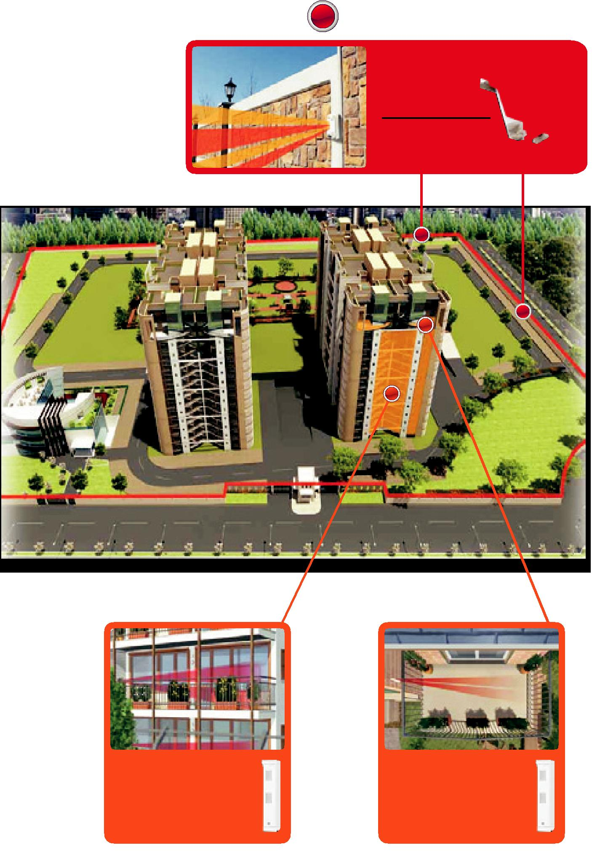

|  |  |
| --- | --- |
| **Residential Societies** | **Defence Level** |
| Though the size of such |  |
| properties make them difficult |  |
| to guard, Vigil provides |  |
| assistance to the security team |  |
| and will alert them to any |  |
| suspicious activity around |  |
| the boundary. |  |

OUTDOOR COMPACT

DETECTOR:

**HX PIR**

Outer Wall

**Defence Level Defence Level**



|  |  |  |
| --- | --- | --- |
| OUTDOOR COMPACT DETECTOR: | | OUTDOOR COMPACT DETECTOR: |
| **FIT PIR** | | **FIT PIR** |
|  |  |  |
| All windows and entrances | | Apartment terraces |

**Commercial Complex**

Vigil’s infra-red rays around the gates and perimeter walls keep commercial complexes secure even when they are deserted by night.

**Defence Level Defence Level Defence Level**

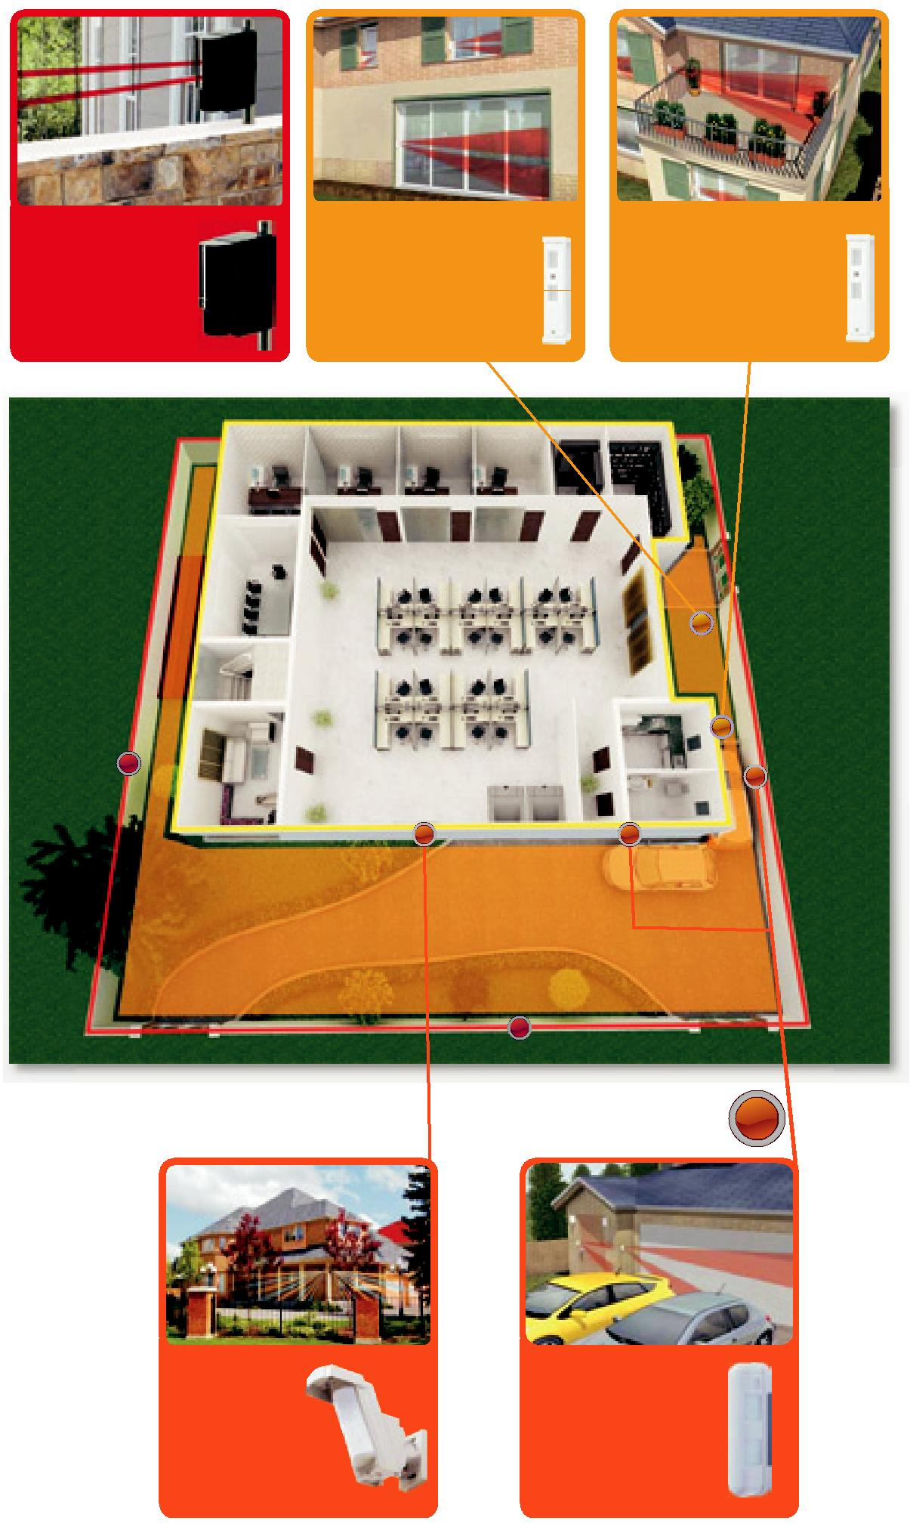

|  |  |  |  |  |  |  |  |  |
| --- | --- | --- | --- | --- | --- | --- | --- | --- |
|  | OUTDOOR COMPACT | | | OUTDOOR COMPACT DETECTOR: | | OUTDOOR COMPACT DETECTOR: | |  |
|  | DETECTOR: | | | **FIT PIR** | | **FIT PIR** | |  |
|  | **AX-100** | | |  |
|  |  |  |  |  |  |
|  |  |  |  | All windows and entrances | | All windows and entrances | |  |
|  | Outer Wall | | |  |
|  |  |  |  |  |  |
|  |  |  |  |  |  |  |  |  |
|  |  |  |  |  |  |  |  |  |
|  |  |  |  |  |  |  |  |  |
|  |  |  |  |  |  |  |  |  |

**Defence Level Defence Level 2**



|  |  |  |
| --- | --- | --- |
| OUTDOOR COMPACT | OUTDOOR COMPACT | |
| DETECTOR: | DETECTOR: | |
| **HX PIR** | **BX PIR** | |
|  |  |  |
| House wall | Car Parking Area | |



The Complete Range of Vigil Security Systems and Products

**AX 100/200 TFR**



The AX-AIR signals a revolution in the perimeter security industry. Easy to use, the AX AIR comprises a point-to-point transmitter and receiver, which cover a long range - AX 100 (approximately 30 meters) and AX 200 (approximately 60 meters).

**HX PIR**

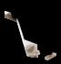

The most important element in a reliable outdoor detector is accuracy in distinguishing a human from a small animal. The exclusive pyro element on board enables the HX PIR to project an ideal detection pattern, allowing for more accurate detection of humans and less false alarms.

**VX PIR**

The VX PIR is not only ideal for intruder prevention it can also be used as a safety warning device to alert you if children enter unsafe areas such as the swimming pool. As it plays a recorded message the instant it detects movement, VX PIR can also be used to automatically greet customers entering a store.



**BX PIR**



BX PIR creates 24m unique dual-side detection areas that protect wide horizontal areas around buildings and will trigger alarm before the break-in. With this unit you don't have to worry about false alarms. It doesn't activate unless the upper and lower detection zones detect a moving object.

**FIT PIR**

Versatile and reliable, FIT PIR is the perfect solution for those outdoor areas where environmental disturbances and small animals may cause false alarms. This compact, invisible outdoor sensor is highly reliable and can be used in various locations such as outside windows, near pools, garages, balconies and balcony doors.

